University Of Engineering and Technology, Lahore
Computer Engineering Department

Course Name: Programming Fundamentals | Course Code: CMPE-112L
Assignment Type: Lab tasks | Dated: 25 May 2026
Semester: First | Session: 2026 Spring
Lab/Project/Assignment #: 1 | CLOs to be covered: CLO 2
Lab Title: Lambda Functions | Teacher Name: Hafiz Muhammad Mubashar
Lab Evaluation:

CLO2 | Apply appropriate programming techniques to create executable programs to solve well defined problems
CLO2 | Level1 | Level2 | Level3 | Level4 | Level5 | Level6
(5)
Total |  |  |  |  |  | /5
Rubrics for Current Lab Evaluation
Scale | Marks | Level | Rubric
Excellent | 5 | L1 | Submitted all lab tasks, BONUS task, have good understanding.
Very Good | 4 | L2 | Submitted the lab tasks but have good understanding
Good | 3 | L3 | Submitted the lab tasks but have weak understanding.
Basic | 2 | L4 | Submitted the lab tasks but have no understanding.
Barely Acceptable | 1 | L5 | Submitted only one lab task.
Not Acceptable | 0 | L6 | Did not attempt
Week 12 LAB
Lambda Functions
Lab Goals/Objectives:
• To understand the definition and purpose of Anonymous Functions (Lambda) in Python.
• To master the syntactic differences between standard named functions (def) and inline expressions.

Equipment Required:

* Computer/Laptop
* Python 3.14
* VS Code or pycharm

Theory:
Python supports the creation of anonymous functions—functions defined without a name—using the lambda keyword.

Lab Work:

Task 1: Single-Argument Lambda Expression (Squaring a Value)
a = lambda x: x * x
print(a(5))

Result:

Task 2: Multi-Argument Lambda Expression (Summing Values)
a = lambda x, y: x + y
print(a(2, 4))

Result:

Task 3: Transforming Iterables with map() and Lambda.
l = [1, 2, 3, 4]
s = list(map(lambda x: x * x, l))
print(s)
Result:

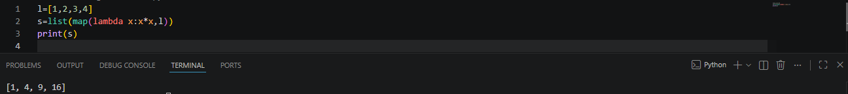

Conclusions:
This lab successfully demonstrates the conciseness and utility of lambda functions in Python. We established that while lambda expressions are structurally restricted to single-line logic, they serve as highly effective tools for quick discardable operations, particularly when passing operational logic inline to higher-order sequence transformers like map().

